How to enable/Disable Powershell Remote Service

-Prerequisites:

Python 3.0 or above

powershell (preferably 2.0 or above)

-Usage:

copy all the files to a local directory, it won't work running off the network share.

open up an administrative command prompt or powershell window

navigate to the folder you placed the files in, make sure you have python in your path(meaning if you open the command prompt you can type in python and it will work)

run:

python Control.py (-e | -d) "<location of your text file containing computers. Separated by new lines>"

then you can do things like

Invoke-Command -ComputerName "HallPublic001" -ScriptBlock { netstat }

Enter-PSSession -ComputerName "HallPublic001" -Credential sneugent

Invoke-Command -ComputerName "HallPublic001" -ScriptBlock { Get-ChildItem C:\Users\\* -recurse -Include "\*.jpg", "\*.doc"}

Invoke-Command -ComputerName "HallPublic001" -ScriptBlock { Get-ChildItem C:\Users\\* -recurse -Include "\*.jpg", "\*.doc", "\*.docx", "\*.pdf" | remove-item –Force }

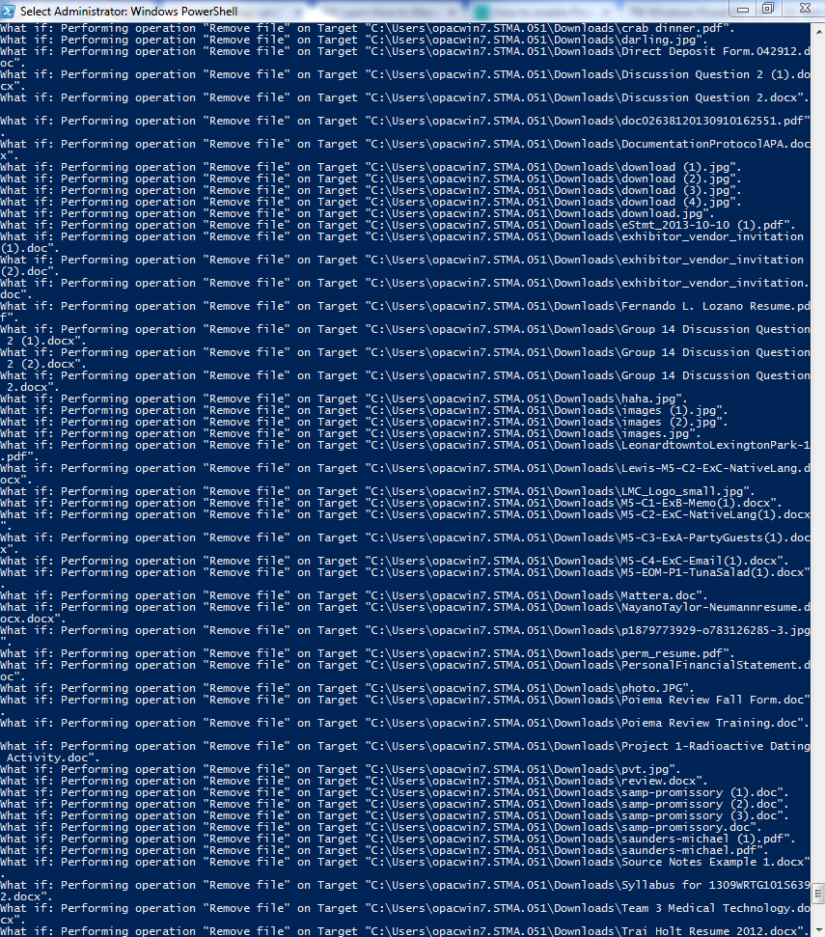

And so on and so forth